NEL4 Module 2:
Network Infrastructure

Live Event: Learner Activity Document


Contents
Activity 1: Network types 1
Scenario background 1
Instructions 1
Activity 2: Network zones 2
Scenario background 2
Instructions 3
Activity 3: Network design activity 4
Instructions 4
Activity 4: VLAN configuration 5
Background 5
Scenario 5
Instructions 6
Reflection 9
Activity 5: Identify collision domains and broadcast domains 10
Instructions 10
Reflection 14
Activity 6: VLAN trunking protocol (VTP) configuration 15
Background 15
Instructions 16
Reflection 19
Activity 7: Inter-VLAN routing 21
Scenario background 21
Instructions 21
Reflection 23
Activity 8: Select appropriate cabling 25
Scenario background 25
Instructions 25
Activity 9: Evaluate and compare network devices 27
Scenario background 27
Instructions 27
Activity 10: The OSI model 29
Scenario background 29
Instructions 29
Instructions 30
Activity 12: IPv4 addressing 35
Introduction 35
Instructions 35
Activity 13: NAT and PAT 40
Introduction 40
Instructions 41
Activity 14: Subnetting practice 44
Instructions 44
Reflection 53
Activity 15: Variable length subnet masks practice: Challenge 54
Instructions 55
Activity 16: Configure DHCP 59
Scenario background 59
Instructions 59
Extension 62
Challenge 62
Activity 17: DNS 63
Scenario background 63
Instructions 63
Extension 65
Activity 18: Static routing 66
Background 66
Instructions 66
Activity 19: Configuring RIPv2 74
Scenario background 74
Instructions 74
Extension 78
Activity 20: Dynamic routing lab EIGRP 80
Background 80
Instructions 80
Activity 21: Recommend a cloud deployment model and service type 89
Scenario background 89
Instructions 89
Discussion and feedback 90

Activity 1: Network types

Scenario background
You are the IT manager for a growing company, TechSolutions Inc., which currently has 50 employees. The company is expanding and expects to double its workforce within the next two years. The current network setup is outdated and needs to be upgraded to support the increased number of users and devices.
TechSolutions Inc. needs a new network infrastructure that will support file sharing, communication, and resource management efficiently. You have two options to consider: a peer-to-peer (P2P) network or a client/server network.

Instructions
Evaluate the following aspects for both network types and make a recommendation on which network to deploy:
- Scalability: How well can the network handle an increase in the number of users and devices?
- Cost: What are the initial setup costs and ongoing maintenance costs for each network type?
- Security: How secure is each network type? Consider data protection, user authentication, and access control.
- Performance: How does each network type perform in terms of speed, reliability, and efficiency?
- Management: How easy is it to manage and maintain each network type? Consider the need for dedicated IT staff and the complexity of network administration.
Research: Gather information on both network types, focusing on the decision points mentioned above.
Analysis: Compare the pros and cons of each network type based on your research.
Recommend: Write a report recommending either a peer-to-peer network or a client/server network for TechSolutions Inc. Justify your decision with evidence from your analysis.

Activity 2: Network zones

Scenario background
You are part of an IT consulting team hired by a company to design its network architecture. The company has specific requirements for internal operations, external partnerships, and public-facing services. Your task is to recommend the appropriate network zones for each requirement and justify your decision.
Employee network
The company needs a secure area for employees to access internal communication tools, such as email, HR portals, and internal file share, as well as services such as DNS and DHCP (no service configuration is required at this stage). Consider:
- Should external users have access to this system?
- How critical is security?
Partner collaboration platform
The company collaborates with external vendors and needs a shared platform for exchanging documents and tracking joint projects. Consider:
- Should internal and external users access the same platform?
- What security measures should be in place to protect sensitive data?
Customer-facing website
The company operates a public website where customers can browse products, access support, and log in to personal accounts. Consider:
- Should this be accessible to the public?
- How do you protect backend systems while allowing public access?
Online payment gateway
Customers use the website to make secure payments. This system needs to handle sensitive customer data while complying with security standards like PCI-DSS. Consider:
- How do you ensure the security of payment data?
- Should this system be isolated from other public-facing services?
File transfer for partners and vendors
External vendors need to upload and download large files for operational purposes. The company wants to restrict access to authorised partners only. Consider:
- Should this service be in a public-facing zone?
- How do you ensure only authorised vendors have access?

Instructions
Read each scenario carefully and determine:
- Who needs access? (Internal users, external partners, or the public.)
- What level of security is required?
Recommend one of the following network zones for each scenario:
- Intranet: Secure internal network accessible only to employees.
- Extranet: A semi-private network that allows access to authorised external users (for example, vendors, partners).
- Perimeter Network (formerly DMZ, or demilitarised zone): A publicly accessible zone designed for external users, often hosting public-facing services like websites or email servers.
Justify your recommendation:
- For each scenario, explain why the chosen network zone is the best fit. Consider security, accessibility, and operational efficiency.

Activity 3: Network design activity

Instructions
Using Packet Tracer, design your proposed network solution to activity 1 and activity 2. Your solution should address the following:
- Scalability: How well can the network handle an increase in the number of users and devices?
- Security: How secure is each network type? Consider data protection, user authentication, and access control.
- Performance: How does each network type perform in terms of speed, reliability, and efficiency?
- Management: How easy is it to manage and maintain each network type? Consider the need for dedicated IT staff and the complexity of network administration.
- Network zones: Some of these can be evidenced through report writing or add them as annotation to you Packet Tracer design.

Activity 4: VLAN configuration
Note: As you progress through this activity you can use the Check Results button to verify the tasks as you go. Select the Assessment Items tab to see the detail of the required tasks.
Your trainer will share the PKT file required for this activity via Webex — download the file and open it in Packet Tracer.

Background
When designing or implementing any network environment, such as a corporate network or lab environment, it is important to identify and understand the network topology and IP addressing schemes that are in use. The following exhibit represents your initial design. The image below provides the VLAN information that should be implemented in the proposed network design.
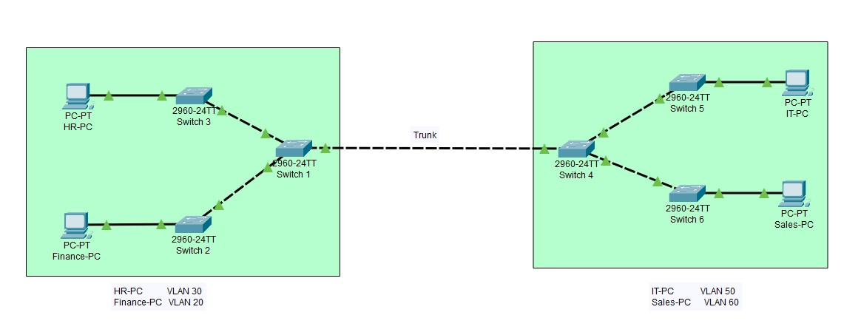

Scenario
TechSolutions Inc is a small business supporting around 70 staff/employees and with approximately 500 customers. The company began with a small single LAN built by one of the founding members of the company who had an interest in IT and networking around five years ago. The original network consisted of Layer 2 access layer switches used to connect to various offices and departments.
With the growth of the business, the number of departments has increased along with the number of network devices and locations.
The company now wants to invest in acquiring advanced network devices so the IT support teams can segment the network into different departments. Before procuring the required team, members and supporting equipment, you have been asked to examine the existing network infrastructure and implement recommendations for the following:
- Provide any necessary network segmentation to ensure all offices and departments can operate efficiently.
- Traffic from different departments must not affect each other and must support being secured with different access limitations. Each office must be isolated from each other.
- Incoming access must be limited to certain departments and services.
- If required, bandwidth should be optimised when necessary.
Objectives
Your initial design has been deployed, and all connectivity is implemented as per the network topology diagram. All IP configuration has been applied to all network devices.
You will now carry out the segmentation configuration tasks required to complete the network design by incorporating some of the topology specification you have identified previously and testing the configuration to ensure that it operates successfully. It is critical that your implementation meets the operational requirements of the organisation.

Instructions
The activity is split into three steps:
- Step 1: Create the department/team VLANs.
- Step 2: Assign ports to VLANs.
- Step 3: Assign devices to each VLAN.

Step 1: Create the department/teams VLANs
- Select the SW2 switch and select the Config tab:
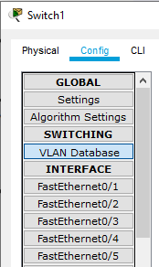
- Select VLAN Database.
- Enter the following parameters:
VLAN Number: 20
VLAN Name: Finance-PC
- Select SW3 switch and enter the following parameters:
VLAN Number: 30
VLAN Name: HR-PC
- Select SW5 switch and enter the following parameters:
VLAN Number: 50
VLAN Name: IT-PC
- Select SW6 switch and enter the following parameters:
VLAN Number: 60
VLAN Name: Sales-PC

Step 2: Assign ports to VLANs
It is essential that the right ports are assigned to the right VLAN. Follow these steps to enable device ports display on the design workspace.
- Select Options on the Packet Tracer Menu:
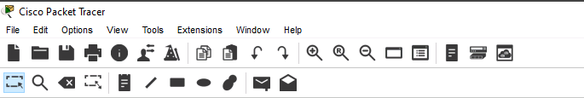
- Select Preferences — a new window will open.
- Put a tick next to Always Show Port Labels in Logical Workspace and close the window:
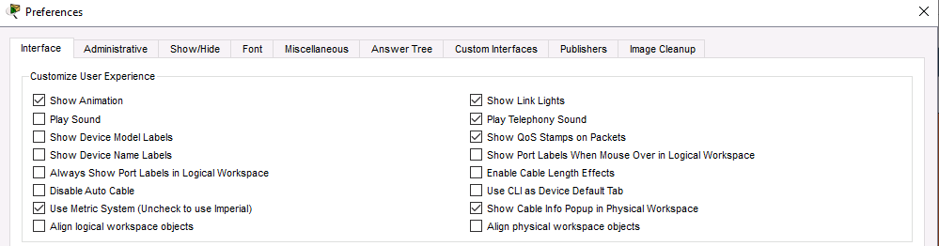
- The port labels should be visible as show below:
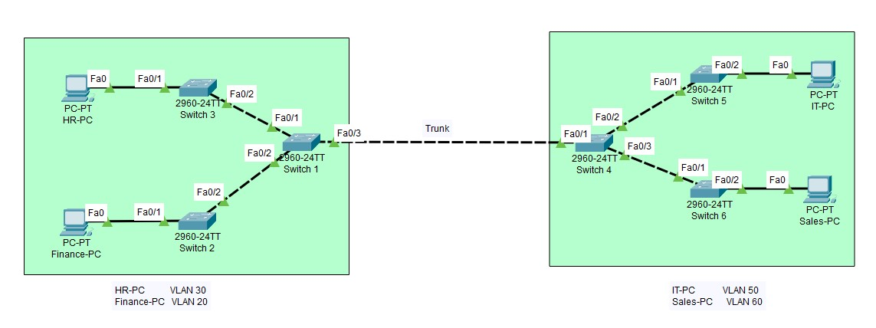
- Make note of the port that the Finance-PC is connected to.
- Select SW2 and select the Config tab.
- Select the port that Finance-PC is connected to.
- On the right pane, Select the dropdown arrow and put a tick next to Finance VLAN.
- Close SW2 menu.
- Add the other devices to their respective VLANs by repeating steps 1 to 9.
Note: There is currently no communication with other VLANs. Inter-VLAN communication is only possible with the support of Layer 3.

Step 3: Assign devices to each VLAN
Ask your trainer for a demonstration on how to add devices to Packet Tracer.
Add additional devices to each VLAN. A ping between these devices should be successful because both PCs are current members of the same VLAN and have correct Layer 3 IP configuration.

Reflection
What did you learn from this practical task that you didn't know before?

How can you apply the knowledge gained from this task to future networking projects?

Activity 5: Identify collision domains and broadcast domains

Instructions
In this activity, you will examine the device types and connections in the network topology. You should identify the amount of collision domains and broadcast domains that exist in the topology.
The amount of collision domains and broadcast domains can have an impact on the efficiency of the network and may not always provide an optimal network topology for data flow, connectivity, and security considerations.

Task 1
Determine the total number of collision domains and broadcast domains in the topology:
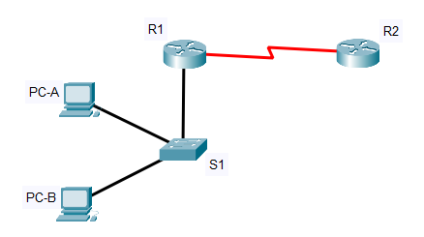
Answer the following questions:
- How many collision domains are there?

- How many broadcast domains are there?

Task 2
The network topology has been expanded to accommodate the inclusion of a new components:
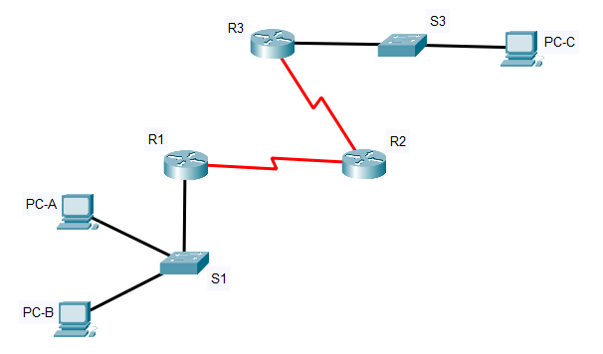
Answer the following questions:
- How many collision domains are there?

- How many broadcast domains are there?

- What changes have occurred?

- How many collision domains would be present if switch S3 is replaced with a network hub device?

Task 3
The network topology has been expanded again with the inclusion of more new components:
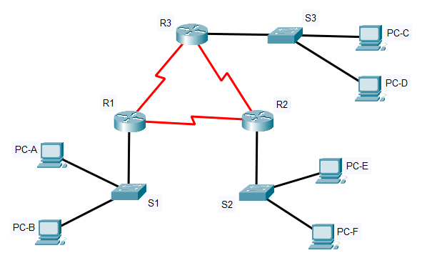
Answer the following questions:
- How many collision domains are there?

- How many broadcast domains are there?

- How many collision domains would be present if all switches are replaced with network hub devices?

Task 4 — Challenge
The network topology has been expanded again with the inclusion of more new components:
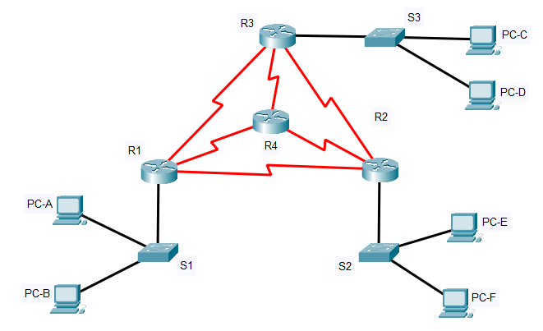
Answer the following questions:
- How many collision domains are there?

- How many broadcast domains are there?

- How many collision domains would be present if all switches are replaced with network hub devices?

Reflection
What information is needed when determining the number of collision and broadcast domain required when creating networks?

Activity 6: VLAN trunking protocol (VTP) configuration
Your trainer will share the PKT file required for this lab via Webex — download the file and open it in Packet Tracer.

Background
In this lab, you will configure VLAN trunking protocol (VTP) to create the required VLANs on switch 1 by enabling it as a VTP server.
The manual configuration of VLANs can be time consuming and prone to human errors. Configuring VTP allows the replication of VLAN information between switches.
Note: There is a minor configuration missing from the instructions that you will need to troubleshoot and resolve. Ask your Trainer for help if you struggle.
Here is the network topology you will work with:
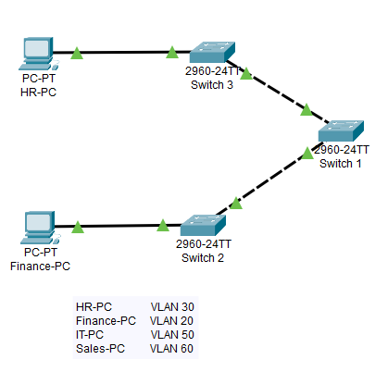

Instructions
Configure the devices as follows:
- SW1: Server mode
- SW2: Client mode
- SW3: Client mode
- VTP domain: QAA
- VTP password: cisco1
Additional information:
- Server mode: Can create, modify, and delete VLANs. Sends updates to other switches.
- Client mode: Receives VLAN updates but cannot modify VLANs.
- Transparent mode: Does not participate in VTP but forwards VTP messages.
- VTP domain: A name that must match across all participating switches.

Step 1: Configure SW1 with VLANs
- Select SW1 to open the configuration menu.
- Under Config, select VLAN Database:
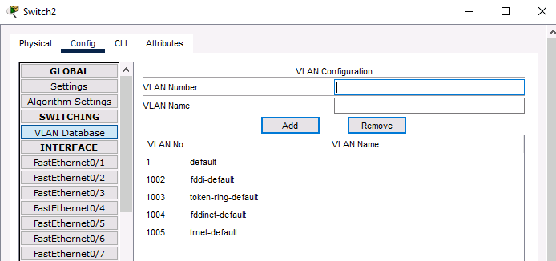

- Enter the following details in the VLAN Number and VLAN Name boxes and select Add:
VLAN Number | VLAN Name
20 | Finance
30 | HR
50 | IT
60 | Sales

Step 2: Configure VTP on SW1
- Select the CLI tab:
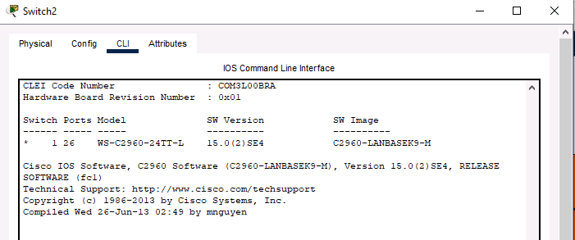
- Enter the following commands into the configuration mode and press Enter after each command. Please ask your tutor if unsure:
Switch>enable
Switch#
Switch#configuration terminal
Enter configuration commands, one per line. End with CNTL/Z.
Switch (config)#
Switch (config)#
vtp mode server
vtp password cisco1

- At the prompt, type the following commands and press Enter after each command:
vtp domain QAA
vtp mode server
vtp password cisco1

Step 3: Configure VTP on SW2
- Select the icon representing switch SW2 in the topology.
- Select CLI tab and press Enter:
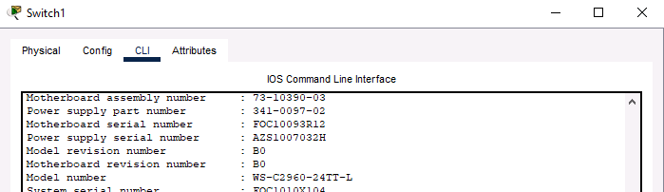
- At the prompt, type the following commands and press Enter after each command:
enable
config t
vtp domain QAA
vtp mode client
vtp password cisco1

Step 4: Configure VTP on SW3
- Select SW3 to open the configuration menu.
- Select CLI tab and press Enter:
- At the prompt, type the following commands and press Enter after each command:
enable
config t
vtp domain QAA
vtp mode client

Step 5: Verify VTP configuration on SW2
- Select SW2 and select the Config tab.
- Select VLAN Database and answer the following question:
  - Are there any of the VLANs you configured replicated from SW1?

Step 6: Verify VTP configuration on SW3
- Select SW3 and select the Config tab.
- Select VLAN Database and answer the following questions:
  - Are there any of the VLANs you configured replicated from SW1?
  - What do you think is missing from the configuration?
  - Where should your solution be implemented?

Reflection
How did VTP simplify VLAN management in your lab setup?

What challenges did you encounter while configuring VTP, and how did you troubleshoot them?

What are the potential risks of using VTP in a large network, and how can they be mitigated?

How does VTP transparent mode differ from client and server modes, and when would you use it in a real-world scenario?

Activity 7: Inter-VLAN routing

Scenario background
When designing or implementing any network environment, such as a corporate network or lab environment, it is important to identify and understand the network topology and IP addressing schemes that are in use. The following exhibit represents your initial design. The diagram below provides the VLAN information that has already been configured.
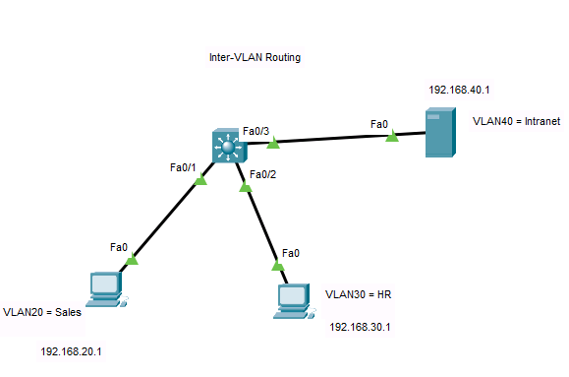
TechSolutions Inc is a small business supporting around 70 staff/employees and with approximately 500 customers. The company began with a small single LAN built by one of the founding members of the company who had an interest in IT and networking around five years ago. The original network consisted of Layer 2 access layer switches used to connect to various offices and departments. With the growth of the business, the number of departments has increased along with the number of network devices and locations.

Instructions
Your initial design has been deployed, and all connectivity is implemented as per the network topology diagram. All IP configuration has been applied to all network devices.
In this lab, you will configure inter-VLAN routing using a layer 3 switch.
Note: There is a minor configuration missing from the instructions that you will need to troubleshoot and resolve. Ask your Trainer for help if you struggle.

Step 1: Create VLAN interfaces to serve as default gateway
The IP addresses assigned to the VLAN interfaces will serve as the default gateway for each VLAN.
Note: Make sure that you are in Config-mode of the switch CLI before completing the next tasks — ask the trainer if you are unsure.
At the prompt, enter the command which follows the # symbol (in bold) and press Enter each time:
- Switch(config)# interface vlan 20
- Switch(config-if)# description Default Gateway SVI for 192.168.20.0/24
- Switch(config-if)# ip add 192.168.20.254 255.255.255.0
- Switch(config-if)# no shut
- Switch(config-if)# exit
- Switch(config)# int vlan 30
- Switch(config-if)# description Default Gateway SVI for 192.168.30.0/24
- Switch(config-if)# ip add 192.168.30.254 255.255.255.0
- Switch(config-if)# no shut
- Switch(config-if)# exit
- Switch(config)# int vlan 40
- Switch(config-if)# description Default Gateway SVI for 192.168.40.0/24
- Switch(config-if)# ip add 192.168.40.1 255.255.255.0
- Switch(config-if)# no shut
- Switch(config-if)# exit
- Switch(config)#

Step 2: Configure access ports
Configure the ports connected to the end devices as access port and assign them to each VLAN.
At the prompt, enter the command which follows the # symbol (in bold) and press Enter each time:
- Switch(config)# interface FastEthernet 0/1
- Switch(config-if)# description Access port to PC1
- Switch(config-if)# switchport mode access
- Switch(config-if)# switchport access vlan 20
- Switch(config-if)# exit
- Switch(config)# interface FastEthernet 0/2
- Switch(config-if)# description Access port to PC2
- Switch(config-if)# switchport mode access
- Switch(config-if)# switchport access vlan 30
- Switch(config-if)# exit
- Switch(config)# interface FastEthernet 0/3
- Switch(config-if)# description Access port to Server0
- Switch(config-if)# switchport mode access
- Switch(config-if)# switchport access vlan 40
- Switch(config-if)# exit

Step 3: Verify connectivity between VLANs
Use the web browser on PC1 to access the intranet server with the IP Address: 192.168.40.1 to verify Inter-VLAN communication as shown below:
- Select HR PC >Desktop>Web Browser.
- In the URL field, enter: 192.168.40.1 and select Go.
- If your configuration is correct, you should be able to view the web page.
- Confirm that you can access the server from a different VLAN using the PC1 web browser.
- If you are unable to ping between the devices, troubleshoot your configuration.

Reflection
What challenges did you encounter while configuring inter-VLAN routing, and how did you troubleshoot them?

Why is a Layer 3 device (router or Layer 3 switch) required for Inter-VLAN communication?

How does a Layer 3 switch Inter-VLAN differs from routing router-on-a-stick, using a router?

In a real-world scenario, when would you prefer using a Layer 3 switch over a router for inter-VLAN routing?

Activity 8: Select appropriate cabling

Scenario background
You are part of the network design team for a new office building for TechCorp Inc. The building will house 200 employees across four floors, with various departments requiring reliable and high-speed network connectivity. Your task is to design the network infrastructure, specifically deciding between using copper STP/UTP cables or fibre optic cables.
TechCorp Inc. needs a robust network infrastructure that can support high-speed data transfer, cover long distances within the building, and minimise interference. You have two options to consider: copper STP/UTP cables and fibre optic cables.

Instructions
Evaluate the following aspects for both cable types and make a recommendation on which to use for the network design.
Speed:
- What are the maximum data transfer speeds for each cable type?
- How do these speeds impact network performance?
Distance:
- What are the maximum effective distances for each cable type without signal degradation?
- How does this affect the layout and design of the network?
Interference:
- How susceptible is each cable type to electromagnetic interference (EMI) and radio frequency interference (RFI)?
- How does this impact the reliability and stability of the network?
Cost:
- What are the initial installation costs and ongoing maintenance costs for each cable type?
- How do these costs fit into the overall budget for the network design?
Research: Gather detailed information on both cable types, focusing on the decision points mentioned above.
Analysis: Compare the pros and cons of each cable type based on your research.
Recommendation: Write a report recommending either copper STP/UTP cables or fibre optic cables for TechCorp Inc.'s network design. Justify your decision with evidence from your analysis.

Activity 9: Evaluate and compare network devices

Scenario background
You are part of the IT team at a mid-sized company, TechNet Solutions, which is planning to upgrade its network infrastructure. The company currently uses a mix of outdated networking devices and needs to decide on the best devices to deploy for improved performance, security, and scalability.
TechNet Solutions has four different network segments: the Administration department, the Development department, the Sales department, and the Production department. Each segment has unique requirements for data traffic, security, and management.
Your task is to evaluate and recommend the most suitable networking devices for each segment.

Instructions
Compare the following devices: Hub, Layer 2 switch, Layer 3 switch, and router. Consider the following aspects for each device:
Functionality:
- How does the device handle data traffic?
- What layer of the OSI model does it operate on?
Performance:
- How does the device impact network speed and efficiency?
- How does it handle network congestion and collisions?
Security:
- What security features does the device offer?
- How does it manage access control and data protection?
Scalability:
- How well can the device handle an increase in the number of users and devices?
- Is it suitable for small, medium, or large networks?
Management:
- How easy is it to manage and configure the device?
- Does it require specialised knowledge or dedicated IT staff?

Summary:
Provide a summary of your proposed suitable networking devices for each segment.

Activity 10: The OSI model

Scenario background
You are part of the IT training team at NetworkPro Academy, tasked with designing a learning module to help new network engineers understand the OSI model. The module should cover the functionalities of each OSI layer, the devices that operate at each layer, and the protocols associated with each layer.
NetworkPro Academy is preparing a comprehensive training programme for new hires. As part of this programme, you need to create an activity that will help learners identify and understand the seven layers of the OSI model, including their functionalities, the devices that operate at each layer, and the protocols used.

Instructions
Create a detailed case study activity that includes the following components:
- Layer identification.
- List and describe each of the seven OSI layers.
- Explain the primary function of each layer.
Function:
- Summarise the function of each layer.
Devices:
- Identify common networking devices that operate at each layer.
- Provide examples of how these devices are used in a network.
Protocols:
- List key protocols associated with each layer.
- Explain the role of each protocol in network communication.
Research: Gather detailed information on each OSI layer, focusing on the functionalities, devices, and protocols.
Analysis: Compare the roles of each layer and how they interact with each other.
Identification: Create a diagram or chart that visually represents the OSI model, including the layers, devices, and protocols.
Presentation: Prepare a presentation or report explaining each layer, the associated devices, and protocols, and how they contribute to network communication.
Activity 11: OSI encapsulation
This simulation activity is intended to provide a foundation for understanding the TCP/IP protocol suite and its relationship to the OSI model. Simulation mode allows you to view the data contents being sent across the network at each layer.
As data moves through the network, it is broken down into smaller pieces and identified so that the pieces can be put back together when they arrive at the destination. Each piece is assigned a specific name (protocol data unit, or PDU) and associated with a specific layer of the TCP/IP and OSI models.
Packet Tracer simulation mode enables you to view each of the layers and the associated PDU. This activity will take you through the process of requesting a web page from a web server by using the web browser application available on a client PC.

Instructions
Topology
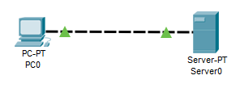

Examine HTTP web traffic

Switch from realtime to simulation mode
In the lower right corner of the Packet Tracer interface are tabs to toggle between Realtime and Simulation mode. Packet Tracer always starts in Realtime mode, in which networking protocols operate with realistic timings.
However, Packet Tracer allows the user to ‘stop time’ by switching to simulation mode. In simulation mode, packets are displayed as animated envelopes, time is event driven, and the user can step through networking events.
- Select the Simulation mode icon to switch from Realtime mode to Simulation mode.
- Select the Show All/None check box to set the visible filters list to none.
- Select Edit Filters, select HTTP, which can be found under the Misc tab.
- Close the Edit ACL Filters window. The visible events should now display HTTP only.

Generate web (HTTP) traffic
Currently the Simulation Panel is empty. There are five columns listed across the top of the Event List within the Simulation Panel. As traffic is generated and stepped through, events appear in the list. The coloured boxes are used to inspect the contents of an event.
Note: The Web Server and Web Client are displayed in the logical pane. The panels can be adjusted in size by hovering next to the scroll bar and dragging left or right when the double-headed arrow appears.
- Select the Web Client (PC0) in the logical pane.
- Select the Desktop tab and click the Web Browser icon to open it.
- In the URL field, enter qa.com and select Go.
- Select Capture/Forward four times. There should be four events in the Event List.
- Look at the Web Client web browser page. Did anything change?

Explore the contents of the HTTP packet
- Select the first coloured square box in the Event List. It may be necessary to expand the Simulation Panel or use the scrollbar directly below the Event List.
The PDU Information at Device: PC0 window now displays. In this window, there are only two tabs (OSI Model and Outbound PDU Details) because this is the start of the transmission. As more events are examined, there will be three tabs displayed, adding a tab for Inbound PDU Details. When an event is the last event in the stream of traffic, only the OSI Model and Inbound PDU Details tabs are displayed.
- Ensure the OSI Model tab is selected. Under the Out Layers column, ensure the Layer 7 box is highlighted.
- What is the text displayed next to the Layer 7 label?
What information is listed in the numbered steps directly below the In Layers and Out Layers boxes?
- Select Next Layer. Layer 4 should be highlighted. What is the Dst Port value?
- Select Next Layer. Layer 3 should be highlighted. What is the Dest. IP value?
- Select Next Layer. What information is displayed at this layer?
- Select the Outbound PDU Details tab.
Information listed under the PDU Details is reflective of the layers within the TCP/IP model.
Note: The information listed under the Ethernet II section provides even more detailed information than the list under Layer 2 on the OSI Model tab. The Outbound PDU Details provides more descriptive and detailed information. The values under DEST MAC and SRC MAC within the Ethernet II section of the PDU Details appear on the OSI Model tab under Layer 2 but are not identified as such.

- What is the common information listed under the IP section of PDU Details as compared to the information listed under the OSI Model tab? Which layer is it associated with?
- What is the common information listed under the TCP section of PDU Details, as compared to the information listed under the OSI Model tab, and with which layer is it associated?
- What is the Host listed under the HTTP section of the PDU Details?
What layer would this information be associated with under the OSI Model tab?
- Select the next coloured square box in the Event List. Only Layer 1 is active (not greyed out). The device is moving the frame from the buffer and placing it on to the network.
- Advance to the next HTTP PDU within the Event List and click the coloured square box. This window contains both In Layers and Out Layers. Notice the direction of the arrow directly under the In Layers column; it is pointing upward, indicating the direction the information is travelling.
- Scroll through these layers making note of the items previously viewed. At the top of the column the arrow points to the right. This denotes that the server is now sending the information back to the client.
Compare the information displayed in the In Layers column with that of the Out Layers column, what are the major differences?
- Select the Outbound PDU Details tab. Scroll down to the HTTP section.
What is the first line in the HTTP message that it displays?
- Select the last coloured square box in the Event List. How many tabs are displayed with this event and why?

Display elements of the TCP/IP Protocol Suite

View additional events
- Close any open PDU information windows.
- In the Event List Filters > Visible Events section, toggle Show All to view all events.
What additional event types are displayed?
These extra entries play various roles within the TCP/IP suite.
If the Address Resolution Protocol (ARP) is listed, it searches MAC addresses.
DNS is responsible for converting a name (for example, qa.com) to an IP address.
The additional TCP events are responsible for connecting, agreeing on communication parameters, and disconnecting the communications sessions between the devices.
Currently there are over 35 possible protocols (event types) available for capture within Packet Tracer.
- Select the first DNS event in the Event List. Explore the OSI Model and PDU Detail tabs and note the encapsulation process.
- As you look at the OSI Model tab with Layer 7 highlighted, a description of what is occurring is listed directly below the In Layers and Out Layers. (‘1. The DNS client sends a DNS query to the DNS server.’). This is very useful information to help understand what is occurring during the communication process.
- Select the Outbound PDU Details tab. What information is listed in the NAME: in the DNS QUERY section?
- Select the last DNS Info coloured square box in the event list. Which device is displayed?
What is the value listed next to ADDRESS: in the DNS ANSWER section of the Inbound PDU Details?
- Find the first HTTP event in the list and click the coloured square box of the TCP event immediately following this event.
- Highlight Layer 4 in the OSI Model tab. In the numbered list directly below the In Layers and Out Layers, what is the information displayed under items 4 and 5? TCP manages the connecting and disconnecting of the communications channel along with other responsibilities. This event shows that the communication channel has been established.
- Select the last TCP event. Highlight Layer 4 in the OSI Model tab. Examine the steps listed directly below In Layers and Out Layers. What is the purpose of this event, based on the information provided in the last item in the list (should be item 4)?

Activity 12: IPv4 addressing

Introduction
In this activity you will configure devices with their IP address and subnet mask.
You will learn how Default Gateway provides the path to other destinations beyond the local network.
Note: Remember to save any files once your activity is complete.
Topology
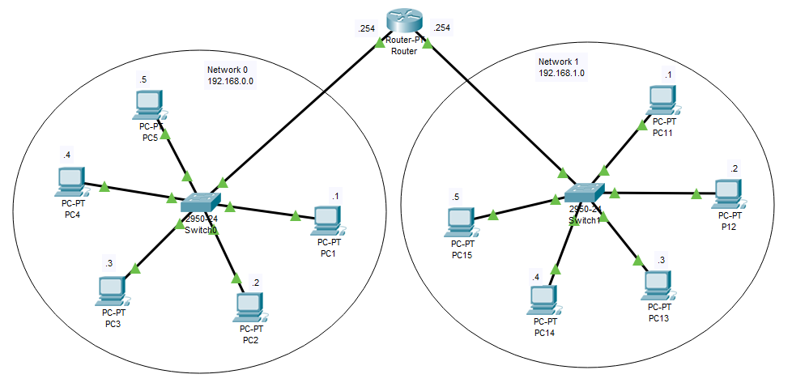

Instructions

Configure the devices with an IP address
The diagram in the Packet Tracer Logical workspace shows two networks connected by a Router:
Network 0: 192.168.0.0
Network 1: 192.168.1.0
The first 24 bits in the IP address define the Network and the remaining eight bits define the host.
The network/host bits are defined by the Subnet Mask: 255.255.255.0
All devices in Network 0 share the same network address but must have a unique host address within that network.
Likewise, all devices in Network 1 share the same network address but again, must have a unique host address.
The table below shows the addressing scheme:
Network 0 |  | Network 1
Device | IP address  Subnet mask | Device | IP address  Subnet mask
PC1 | 192.168.0.1  255.255.255.0 | PC11 | 192.168.1.1  255.255.255.0
PC2 | 192.168.0.2  255.255.255.0 | PC12 | 192.168.1.2  255.255.255.0
PC3 | 192.168.0.3  255.255.255.0 | PC13 | 192.168.1.3  255.255.255.0
PC4 | 192.168.0.4  255.255.255.0 | PC14 | 192.168.1.4  255.255.255.0
PC5 | 192.168.0.5  255.255.255.0 | PC15 | 192.168.1.5  255.255.255.0

- In Network 0, Select PC1>Desktop>IP Configuration.
- Select Static.
- Using the above table for reference, enter the IP Address and Subnet Mask.
- Close the IP Configuration window.
Repeat steps 1 to 4 for the remaining four PCs in Network 0.
Continue with the five PCs in Network 1.
Note: Remember, the network address for these devices is slightly different.

Configure the router ports
Some of the router configuration has already been configured for this activity, but you will need to configure the Interfaces.
Just like the PCs, each interface needs a Network ID and a unique Host number. The last IP Address in the range 1 to 254 has been allocated:
Router
Network 0 |  | Network 1
FastEthernet0/0 | IP Address  Subnet Mask | FastEthernet1/0 | IP Address  Subnet Mask
FastEthernet0/0 | 192.168.0.254  255.255.255.0 | FastEthernet1/0 | 192.168.1.254  255.255.255.0

- Select Router>Config>FastEthernet0/0.
- In the IP Configuration window, enter the IP Address and Subnet Mask (from the table above).
- Turn the interface On by selecting the Port Status check box.
- Repeat steps 1 to 3 for FastEthernet1/0.
- Close the Config window.

Introducing the Default Gateway
All device interfaces are now connected and configured.
- Ping PC1 to PC5
Successful: Yes/No?
- Ping PC1 to Router
Successful: Yes/No
- Ping PC11 to PC15
Successful: Yes/No
- Ping PC11 to Router
Successful: Yes/No
- Ping PC1 to PC11
Successful: Yes/No
You appear to be able to connect to devices within each network, but you were not successful when trying to connect to the other network.
All devices are aware of their connections, but they have no idea where they should go, or who they should ask when trying to connect to another network.
This is where the Default Gateway can help. It opens the door to other networks. Therefore, every device needs to know where the entrance/exit can be found.
Let’s see what happens when you configure each device with the Default Gateway. Only the PCs in Network 0 and Network 1 need this information.

Configure a device with the Default Gateway
- Select PC1>Desktop>IP Configuration.
- In the IP Configuration window, enter the value of the Routers FastEthernet0/0 IP address:
Default Gateway: 192.168.0.254
- Close the window
- Repeat steps 1 to 3 for PCs 2 to 5
- Again, repeat steps 1 to 3 for PCs 11 to 15 making sure you use the value of the Routers FastEthernet1/0 IP address
- If your configuration settings are all correct, you should see the following score:
- Investigate and resolve any issues before continuing.

Verify the connections
In the lower right corner of the Packet Tracer interface are tabs to toggle between Realtime and Simulation mode.
- Select the Simulation mode icon to switch from Realtime mode to Simulation mode.
- Toggle the Show All/None check box to set the visible filters list to none.
- Select Edit Filters, select ICMP, which can be found under the IPv4 tab.
- Close the Edit ACL Filters window. The Visible Events should now display ICMP only.
- Open the PDU List Window by selecting the left arrow at the very bottom of the screen.
- Select the Delete button to remove any existing PDUs from the list.
- Select a Simple PDU by clicking the closed envelope on the top horizontal toolbar. Move your cursor to the display area of your screen.
- Select on PC1 to establish the source. Move your cursor to PC11 and click to establish the destination.
- Select Auto Capture / Play from the Play Controls area of the Simulation Panel and observe the traffic generated by the Ping request. Make a note of your observations below:
- Repeat the test for the following:
Source: PC12
Destination: PC2
- Make a note of your observations below:

What if?...
By making a change to the configuration, what impact did it have on the network?
Action taken | Observations
Additional comments:

Activity 13: NAT and PAT

Introduction
The Learning Server and Server0 shown in the topology diagram are connected to the private network: 10.10.10.0/24.
In this Packet Tracer activity, you will configure Router2 with:
- Static Network Address Translation (NAT).
The Learning Server can then be advertised with a public address: 88.40.12.3/28.
- Port Address Translation (PAT).
Server0 will be restricted to Port 80 with a public address: 88.40.12.4/28.
Note: Remember to save any files once your activity is complete.
Topology
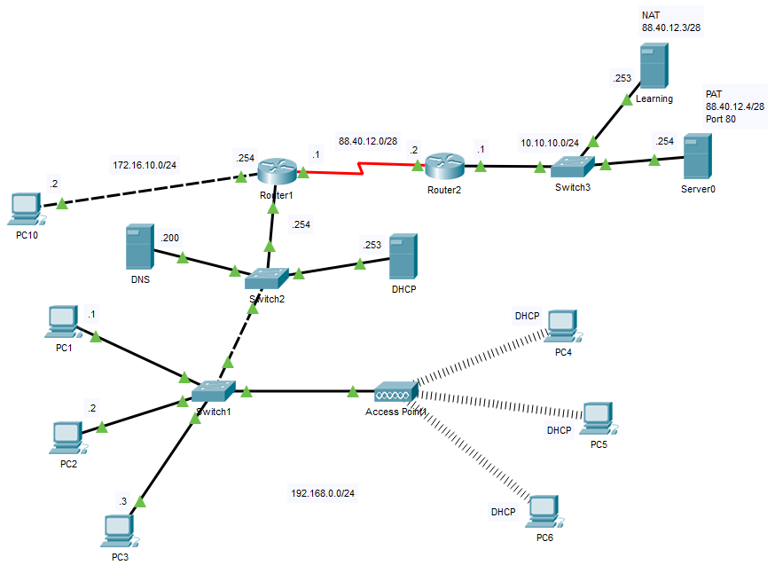

Instructions

Configure a Router with Static NAT
For this activity you are going to use the Command Line Interface (CLI) to configure this device:
- Select Router2>CLI and enter the following commands:
Router> enable
Router# configure terminal
Router(config)# int s2/0
Router(config-if)# ip nat outside
Router(config-if)# int f0/0
Router(config-if)# ip nat inside
Router(config-if)# exit
Router(config)# ip nat inside source static 10.10.10.253 88.40.12.3
Router(config)# Exit
Router#
- Confirm the configuration by entering:
Router# show ip nat translations
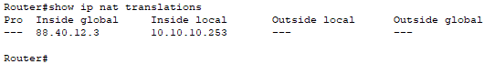
- Close the CLI window

Verify the configuration
Use the web browser on PC10 to access the Learning Server with the public IP Address: 88.40.12.3 to verify the configuration:
- Select PC10>Desktop>Web Browser.
- In the URL field type: 88.40.12.3 and click Go
- If your configuration is correct, you should be able to view the web page

Configure a router with PAT
For this activity you are going to use the Command Line Interface (CLI) to configure this device:
- Select Router2>CLI and enter the following commands:
Router> enable
Router# configure terminal
Router(config)# int s2/0
Router(config-if)# ip nat outside
Router(config-if)# int f0/0 (only required if not previously configured)
Router(config-if)# ip nat inside
Router(config-if)# exit
Router(config)# ip nat inside source static tcp 10.10.10.254 80
88.40.12.4 80
Router(config)# Exit
Router#
- Confirm the configuration by entering:
Router# show ip nat translations
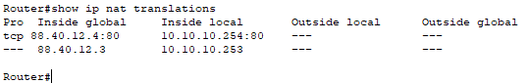
- Close the CLI window

Verify the configuration
Use the web browser on PC10 to access Server0 with the public IP Address: 88.40.12.4 to verify the configuration:
- Select PC10>Desktop>Web Browser.
- In the URL field, type: http://88.40.12.4 and select Go.
- If your configuration is correct, you should be able to view the web page.
To prove Port Address Translation:
- In the URL field type: https://88.40.12.4 and select Go.
- Why is there no response from Server0?
- What Port number is allocated to https?
Given the results from above, you should be able to confirm there are no Port restrictions on the Learning Server:
- In the URL field type: https://88.40.12.3 and select Go.
- The response from Server0 should be successful.

Remove the configuration
The process is similar when removing the translation:
- Click Router2>CLI and enter the following commands:
Router> enable
Router# configure terminal
Router(config)# int s2/0
Router(config-if)# no ip nat outside
Router(config-if)# int f0/0
Router(config-if)# no ip nat inside
Router(config-if)# exit
Router(config)# no ip nat inside source static 10.10.10.253 88.40.12.3
Router(config)# no ip nat inside source static tcp 10.10.10.254 80 88.40.12.4 80
Router(config)# Exit
Router#
- Confirm the configuration is removed by entering:
Router# show ip nat translations
- Close the CLI window.
- Confirm that you are no longer able to access the Servers with the public IP addresses from the PC10 Web Browser. Confirmed: Yes/No.

Activity 14: Subnetting practice
In this activity, you will examine a network diagram. Having the ability to calculate the necessary number of subnets when presented with a network architecture is crucial. Several scenario topologies, a base network address, and a mask will all be provided in this lab.
The network address will require being subnetted, and an IP addressing scheme will need to be proposed to support the number of subnets shown in the topology diagram. You are required to calculate the amount of bits to borrow, the number of hosts per subnet, and the possibility for expansion.

Instructions

Task 1: Identify the subnetting requirements for Topology 1
An overview of the entire network topology is illustrated in the diagram. You have been allocated the network address 192.168.40.0/24 to subnet, utilising the following topology for this task. After determining the required number of networks, create a suitable addressing scheme.
- How many subnets are there in the network topology?

- How many bits should you borrow to create the required number of subnets?

- How many usable host addresses per subnet are in this addressing scheme?

- What is the new subnet mask in dotted decimal format?

- How many subnets are available for future use?

Fill in the following table with the subnet information:
Subnet  number | Subnet address | First usable host address | Last usable host address | Broadcast address

Task 2: Identify the subnetting requirements for Topology 2
The network topology from Task 1 has been expanded to accommodate the inclusion of a new components. Use the 192.168.40.0/24 network address to provide addresses to the network devices and then design a new addressing scheme to support the additional network requirement.

- How many subnets are there?

- How many bits should you borrow to create the required number of subnets?

- How many usable host addresses per subnet are in this addressing scheme?

- What is the new subnet mask in dotted decimal format?

- How many subnets are available for future use?

Fill in the following table with the subnet information:
Subnet  number | Subnet address | First usable host address | Last usable host address | Broadcast address

Task 3: Identify the subnetting requirements for Topology 3: Challenge
The network topology from Task 2 has been expanded to accommodate the inclusion of new components with a new LAN added to R2, a redundant link between R1 and R3, and a new PC added to switch S3. Use the 192.168.40.0/24 network address to provide addresses to the network devices. Also provide an IP address scheme that will accommodate these additional devices. For this topology, assign a subnet to each network.
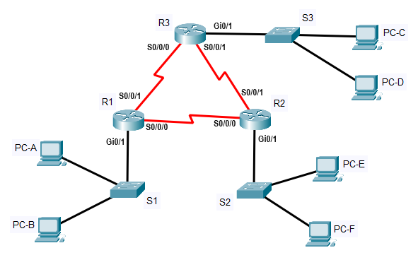

- How many subnets are there?

- How many bits should you borrow to create the required number of subnets?

- How many usable host addresses per subnet are in this addressing scheme?

- What is the new subnet mask in dotted decimal format?

- How many subnets are available for future use?

Fill in the following table with the subnet information:
Subnet  number | Subnet address | First usable host address | Last usable host address | Broadcast address

Fill in the following table with IP addresses and subnet masks for the router interfaces:
Device | Interface | IP address | Subnet mask
R1 | Gi 0/1
 | S 0/0/0
 | S 0/0/1
R2 | Gi 0/1
 | S 0/0/0
 | S 0/0/1
R3 | Gi 0/1
 | S 0/0/0
 | S 0/0/1

Fill in the following table with the IP addresses and subnet masks for devices in the LAN as displayed in topology:
Device | IP address | Subnet mask | Default Gateway
PC-A | Gi 0/1
PC-B | S 0/0/0
PC-C | S 0/0/1
PC-D | Gi 0/1
PC-E | S 0/0/0
PC-F | S 0/0/1

Task 4: Identify the subnetting requirements for Topology 4: Challenge
The network was modified to accommodate changes in the organisation. The 192.168.40.0/24 network address is used to provide the addresses in the network.
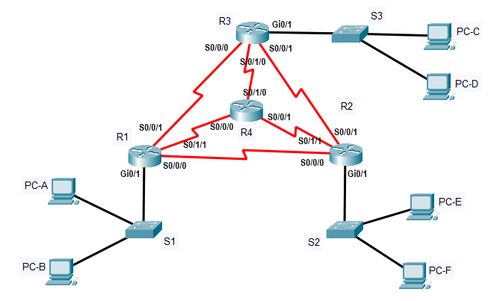
- How many subnets are there?

- How many bits should you borrow to create the required number of subnets?

- How many usable host addresses per subnet are in this addressing scheme?

- What is the new subnet mask in dotted decimal format?

- How many subnets are available for future use?

Fill in the following table with the subnet information:
Subnet  number | Subnet address | First usable host address | Last usable host address | Broadcast address

Reflection
What information is needed when determining an appropriate addressing scheme for a network?

After the subnets are assigned, will all the host addresses be used in each subnet?

Activity 15: Variable length subnet masks practice: Challenge
In this activity, you will examine a network diagram. Having the ability to calculate the necessary number of subnets when presented with a network architecture is crucial.
Not all organisations require subnets of equal size, thus subnetting may require more advanced techniques to ensure that network can operate efficiently using optimal IPv4 addressing.
You are required to calculate the number of bits to borrow, the number of hosts per subnet, and the possibility for expansion.
The organisation has a network address of 172.18.0.0/16 to be divided as illustrated in the following topology. You must choose an addressing scheme that can accommodate the number of networks and hosts in the topology.
You should begin by identifying the largest subnets and calculating the VLSM scheme to the small subnet requirements. This creates a simple hierarchical approach.
Topology
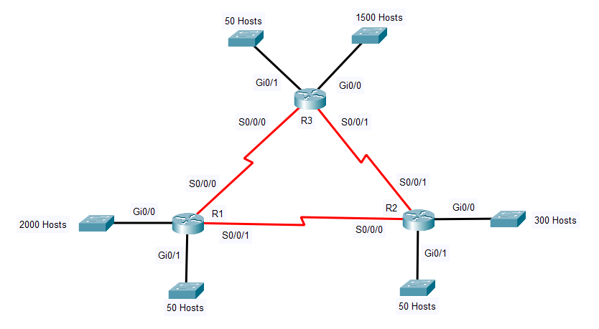

Instructions

Step 1: Determine the number of subnets in the network topology
- How many subnets are there?

- How many bits should you borrow to create the largest subnet of 2000 hosts?

- How many bits should you borrow to create the subnet of 1500 hosts?

- How many bits should you borrow to create the subnet of 300 hosts?

- How many bits should you borrow to create the subnet of 50 hosts?

- How many usable hosts (maximum) are supported on the subnet that must contain 2000 hosts?

- How many usable hosts (maximum) are supported on the subnet that must contain 1500 hosts?

- How many usable hosts (maximum) are supported on the subnet that must contain 300 hosts?

- How many usable hosts (maximum) are supported on the subnet that must contain 50 hosts?

Step 2: Record the subnet information
Fill in the following table with the subnet information:
- Subnet 0 should contain 2000 hosts.
- Subnet 1 should contain 1500 hosts.
- Subnet 2 should contain 300 hosts.
- Subnet 3 should contain 50 hosts on R1.
- Subnet 4 should contain 50 hosts on R2.
- Subnet 5 should contain 50 hosts on R3.
- Subnet 6 should contain R1 and R2.
- Subnet 7 should contain R2 and R3.
- Subnet 8 should contain R1 and R3.

Subnet  number | Subnet address | First usable host address | Last usable host address | Broadcast address
0
1
2
3
4
5
6
7
8

Step 3: Assign addresses to network devices in the subnets
Fill in the following table with IP addresses and subnet masks for the router interfaces:
Device | Interface | IP address | Subnet mask
R1 | Gi0/0
 | Gi0/1
 | S0/0/0
 | S0/0/1
R2 | Gi0/0
 | Gi0/1
 | S0/0/0
 | S0/0/1
R3 | Gi0/0
 | Gi0/1
 | S0/0/0
 | S0/0/1

Complete the following statements by filling in the blanks with the correct information:
- A network containing 2000 hosts requires hosts bits. This leaves

network bits remaining, expressed as prefix-length or a subnet mask of [blank]. This formula requires the IP value in the third octet to increment in values of [blank].

/

- A network containing 1500 hosts requires [blank] hosts bits. This leaves [blank] network bits remaining, expressed as prefix-length /[blank] or a subnet mask of [blank]. This formula requires the IP value in the third octet to increment in values of [blank].

/

- A network containing 300 hosts requires [blank] hosts bits. This leaves [blank] network bits remaining, expressed as prefix-length /[blank] or a subnet mask of [blank]. This formula requires the IP value in the third octet to increment in values of [blank] .

/

- A network containing 50 hosts requires [blank] hosts bits. This leaves [blank] network bits remaining, expressed as prefix-length /[blank] or a subnet mask of [blank]. This formula requires the IP value in the fourth octet to increment in values of [blank].
/

- A WAN link containing 2 hosts can require [blank] hosts bits. This leaves [blank] network bits remaining, expressed as prefix-length /[blank] or a subnet mask of [blank]. This formula requires the IP value in the fourth octet to increment in values of [blank].
/

Note: On a point-to-point WAN link, it is also possible to implement /31 as a broadcast address is not required. See the following link for more information: https://www.ietf.org/rfc/rfc3021.txt

Activity 16: Configure DHCP

Scenario background
TechCorp Inc is a medium size organisation working within the retail sector. The organisation has around 200 employees across three centres: London, Oxford, and Manchester. The London office is where the Sales and HR departments are located, with 200 people in Sales and 25 working in HR. There is also a small IT presence consisting of 10 staff. You are part of the IT implementation project team in London. A new project is underway to configure the London office with a DHCP server that will allocate automatic IP addresses to end devices.

Instructions
In this activity, you will use packet tracer to configure a DHCP server on the 192.168.2.0 London office and then configure the clients in London office to obtain their IP addresses via the DHCP server.

Step 1: Design the network
Note: Create a similar network shown below using packet tracer:
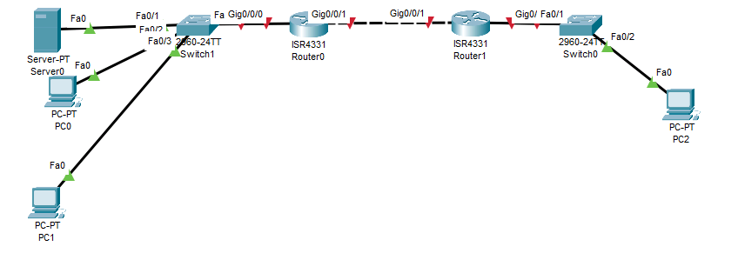
IP address scheme table:
Device | Interface | IP address | Subnet mask
Router0 | Gig0/0/0 | 192.168.1.254 | 255.255.255.0
Router0 | Gig0/0/1 | 130.30.10.1 | 255.255.0.0
Router1 | Gig0/0/0 | 192.168.2.254 | 255.255.255.0
Router1 | Gig0/0/1 | 130.30.10.2 | 255.255.0.0

Step 2: Configure IP address on Router0
- Select Router0 to bring up the properties window.
- Select the config tab.
- Select GigabitEthernet 0/0.
- Enter the following IP configurations:
IP Address: 192.168.1.254
Subnet Mask: 255.255.255.0
- Put a tick in the On box.
- Select GigabitEthernet 0/1.
- Enter the following IP configurations:
IP Address: 130.30.10.1
Subnet Mask: 255.255.0.0
- Put a tick in the On box.
- Close the Router0 properties window.

Step 3: Configure Server0 with IP address and default gateway
- Select Server0 to bring up the properties screen.
- Select the desktop tab.
- Select IP configuration.
- Enter the following IP configurations:
IP Address: 192.168.1.253
Subnet Mask: 255.255.255.0
Default gateway: 192.168.1.254
- Close the IP configuration screen.

Step 4: Configure IP address on Router1
- Select Router1 to bring up the properties window.
- Select the config tab.
- Select GigabitEthernet 0/0..
- Enter the following IP configurations:
IP Address: 192.168.2.254
Subnet Mask: 255.255.255.0
- Put a tick in the On box.
- Select GigabitEthernet 0/1
- Enter the following IP configurations:
IP Address: 130.30.10.1
Subnet Mask: 255.255.0.0
- Put a tick in the On box.
- Close Router1 properties window.

Step 5: Configure server0 with a DHCP scope
- Select Server0, and click the services tab.
- Select the button on the left for DHCP. Set the service to On.
- Enter the following settings:
Default Gateway: 192.168.1.254
DNS: 192.168.1.253
Start IP Address: 192.168.1.10
Subnet Mask: 255.255.255.0
Maximum number of Users: 50
- Select Save to add the new address scope.

Step 6: Configure PC0 and PC1 as DHCP client
- Select PC0.
- Select the Desktop tab and Select IP configuration.
- Enable DHCP by selecting the DHCP button. Notice that an IP address and other parameters have been automatically assigned.
- Close the IP configuration window.
- Select the Command Prompt.
- Type ipconfig /release and press Enter.
- Notice that PC0 is now configured with 0.0.0.0 IP address.
- Type ipconfig /renew and press enter. Notice that PC0 is now configured with IP address from the scope we created earlier on.

Step 7: Verify connectivity
- Type ping 192.168.1.253 to ping the server address.
- You should receive a reply from the server.
- Close the configuration window.
- Troubleshoot if the ping was unsuccessful.
Make sure to save this lab as it is required for the DNS lab.

Extension
What are the benefits of using DHCP?

Why do some devices and interfaces need to be assigned static IP addresses when using DHCP?

Challenge
You have been placed in charge of setting up a new centre in Manchester with 12 users.
In Manchester, you will set up a new private network with three PCs, a DHCP server, a web server, and a router. You will also need to decide whether you will use a switch or a hub. The size of the Manchester office is not expected to change.
You were told you have a choice between the following networks – choose the one most suitable:
- 172.19.6.0/28
- 192.168.109.56/29
- 192.168.6.0/30
Create a sample network on packet tracer which fulfils the above requirements.
The servers and gateway should be assigned static addresses. The remaining devices should receive their IP addresses dynamically.

Activity 17: DNS

Scenario background
TechCorp Inc is a medium size organisation working within the retail sector. The organisation has around 200 employees across three centres: London, Oxford, and Manchester. The London office is where the Sales and HR departments are located, with 200 people in Sales and 25 working in HR. There is also a small IT presence consisting of 10 staff. You are part of the IT implementation project team in London. A new project is underway to configure the London office with a DHCP server that will allocate automatic IP addresses to end devices.

Instructions
In this activity, you will use the packet tracer design from the previous lab (DHCP) to configure a DNS server for the London office and then configure the clients in London office to use DNS to resolve hostnames.

Step 1: Load the network from DHCP lab
Use the network design from the previous lab (DHCP):

Step 2: Configure DNS on the Server0
- Select Server0.
- In the Server configuration window, select the Services tab.
- Select the button on the left for DNS.
- Verify the service is On and configure the following:
Name: www.qa.com
Address: 192.168.1.253
- Select the Add button.
- Your configuration should be the same as shown below: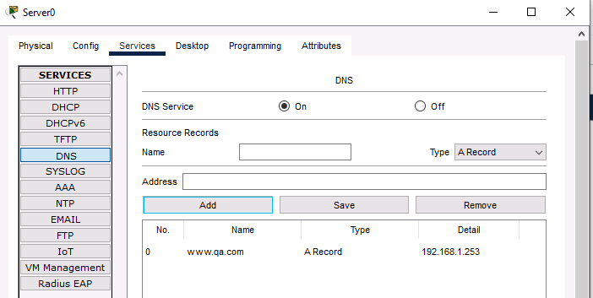

Note: Additional domain names can be added in this fashion. For example, pc0 and the corresponding IP address.

Step 3: Configure DNS configuration on PC0
- Select PC0 to bring up the properties screen.
- Select the desktop tab.
- Select IP configuration and check to make sure the previously configured DNS address is: 192.168.1.253
- Close the PC configuration window.

Step 4: Verify DNS name resolution
- Select PC0.
- Select the Desktop tab.
- Select the Command Prompt button (a Command Prompt window opens.)
- Type ping www.qa.com (the URL of the Server) and press Enter.
- Note: You should get a reply from the server. (If not, proceed to troubleshoot.)
- Close the Command Prompt window.

Step 5: Open a web page
- From the desktop of PC0, Select the Web Browser button. (A simulated web browser opens.)
- Type www.qa.com (the URL of the Server) into the URL box and select the Go button.
- A web page should appear. Close the PC configuration window.
Note: This demonstrates that DNS is required when using hostname to reference network services.

Extension
What are the benefits of using DNS?

What are the different types of addresses for DNS and why would they be used?

Activity 18: Static routing

Background
When working in any network environment, such as a corporate network or lab environment, you must know how to determine the appropriate path and how to properly configure packet forwarding between network routers. In this activity, you will examine device configuration using Packet Tracer. You will then manually configure a static route to a remote network to ensure reachability throughout the network. Connectivity already exists but not all networks are accessible. The Job Aid displays the existing configuration on all routers in the activity.
Device name | Interface | IP address | Connection to
Atlanta | Gi 0/0 | 10.101.1.1 /30 | Gi0/0 New-York
 | Gi 0/2 | 10.103.1.1 /30 | Gi0/2 Chicago
New-York | Gi 0/0 | 10.101.1.2 /30 | Gi0/0 Atlanta
 | Gi 0/1 | 10.102.1.1 /30 | Gi0/1 Chicago
Chicago | Gi 0/1 | 10.102.1.2 /30 | Gi0/1 New-York
 | Gi 0/2 | 10.103.1.2 /30 | Gi0/2 Atlanta

Instructions

Task 1: Confirm existing reachability

Step 1: Connect to the Atlanta router
In this task, you will connect to the console of the Atlanta router and test reachability. Connectivity can be verified by confirming that all connections are green on the topology diagram. This indicates the interface are enabled and a link is established.
Perform the following:
- Select the Atlanta router in the diagram.
- Ensure the CLI tab is selected.
- In the console window, press Enter.
- You should see the device name displayed as follows: Atlanta>
- At the prompt, type the following command and press Enter: Show ip route
- The routing table of Atlanta router is displayed: 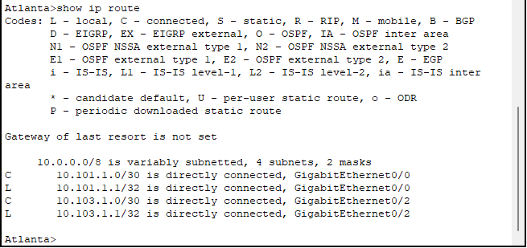
- You will see that the routing table contains a route for the following networks:
10.101.1.0/30
10.103.1.0/30
- There is no route present for the network 10.102.1.0 /30 that exists between New-York and Chicago routers.
- Attempt to reach the 10.102.1.0 network by typing the following command and press Enter:
Ping 10.102.1.1
Ping 10.102.1.2
- Both pings will be unsuccessful.
- Close the Atlanta router connection window.

Step 2: Connect to the New-York router
In this step, you will connect to the console of the New-York router and test reachability.
Perform the following:
- Click the New-York router in the diagram.
- Ensure the CLI tab is selected.
- In the console window, press Enter.
- You should see the device name displayed as follows: New-York>
- At the prompt, type the following command and press Enter: Show ip route

- The routing table of New-York router is displayed:
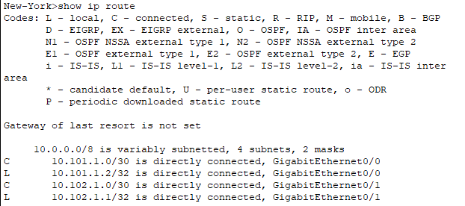
- You will see that the routing table contains a route for the following networks:
10.101.1.0/30
10.102.1.0/30
- There is no route present for the network 10.103.1.0 /30 that exists between Atlanta and Chicago routers.
- Attempt to reach the 10.103.1.0 network by typing the following command and press Enter:
Ping 10.103.1.1
Ping 10.103.1.2
- Both pings will be unsuccessful.
- Close the New-York router connection window.

Step 3: Connect to the Chicago router
In this step, you will connect to the console of the Chicago router and test reachability.
Perform the following steps:
- Select the Chicago router in the diagram.
- Ensure the CLI tab is selected.
- In the console window, press Enter.
- You should see the device name displayed as follows: Chicago>
- At the prompt, type the following command and press Enter: Show ip route

- The routing table of Chicago router is displayed:
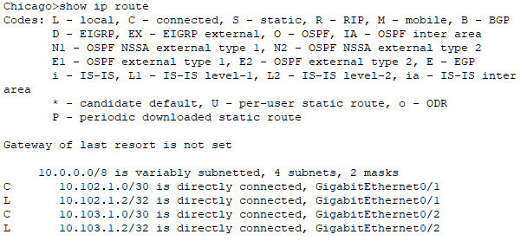
- You will see that the routing table contains a route for the following networks:
10.102.1.0 /30
10.103.1.0 /30
- There is no route present for the network 10.101.1.0 /30 that exists between Atlanta and Chicago routers.
- Attempt to reach the 10.101.1.0 network by typing the following command and press Enter:
Ping 10.101.1.1
Ping 10.101.1.2
- Both pings will be unsuccessful.
- To confirm reachability exists to other networks, attempt to reach the 10.102.1.0 network by typing the following command and press Enter:
Ping 10.102.1.1
Ping 10.102.1.2
- Both pings will be successful. The success rate may be 80% because initially there was no ARP information for the destination. Therefore, an ARP request was sent, followed by the ICMP ping packet.
- Repeat the ping to verify 100% success rate.
- Close the Chicago router connection window.

Task 2: Configure a static route from Atlanta to the New-York to Chicago network
In this task, the Atlanta router must be configured with a static route to the network 10.102.1.0. Either static routing or a dynamic routing protocol is necessary to provide reachability. It’s important to differentiate between connectivity and reachability.
Perform the following steps:
- Select the Atlanta router in the diagram and press Enter.
- At the prompt, type the following command and press Enter: enable
- This places you in privilege exec mode which provides additional permissions. The prompt changes from Atlanta> to Atlanta# (hash symbol).
- At the prompt, type the following command and press Enter: Configure terminal
- You are now placed in global configuration mode which allows device-wide configuration.
- You will now manually configure a static route by entering the command using the format:
ip route <destination network id> <network mask> <next hop IP address>
- Type the following command in the prompt and press Enter:
Ip route 10.102.1.0 255.255.255.252 10.101.1.2
A static route has been created on the Atlanta router to reach the network between New-York and Chicago. You have instructed the Atlanta router to use the New-York router (next hop IP address) as the desired path to the destination network. Alternatively, you could have chosen the Chicago router as the next hop.
- To display the routing table and confirm the new route is present, in the prompt type the following command and press Enter: Do show ip route
- You should now see the entry displayed with the Code S for Static routes. The administrative distance should be 1, and a metric of 0 [1/0].
- To confirm reachability exists to other networks, attempt to reach the 10.102.1.0 network by typing the following command and pressing Enter:
Do ping 10.102.1.1
Do ping 10.102.1.2
Only pings to 10.102.1.1 will be successful. The success rate may be 80% because initially there was no ARP information for the destination. Therefore, an ARP request was sent, followed by the ICMP ping packet.
The pings sent to 10.102.1.2 are unsuccessful because the packets sent to Chicago router are sent via New-York from a source address of 10.101.1.1 on the Atlanta router. This network does not exist on the Chicago router and therefore a reply cannot be forwarded. The New-York router is able to reply as the network 10.101.1.0 does exist in the New-York routing table.

Task 3: Configure a static route from New-York to the Atlanta to Chicago network
In this task, the New-York router must be configured with a static route to the network 10.103.1.0. Either static routing or a dynamic routing protocol is necessary to provide reachability. It’s important to differentiate between connectivity and reachability.
Perform the following steps:
- Select the New-York router in the diagram and press Enter.
- In the prompt type the following command and press Enter: enable
- This places you in privilege exec mode which provides additional permissions. The prompt changes from New-York> to New-York# (hash symbol).
- In the prompt, type the following command and press Enter: Configure terminal
- You are now placed in global configuration mode which allows device-wide configuration.
- You will now manually configure a static route by entering the command using the format:
ip route <destination network id> <network mask> <next hop IP address>
- In the prompt type the following command and press Enter:
Ip route 10.103.1.0 255.255.255.252 10.101.1.1
A static route has been created on the New-York router to reach the network between Atlanta and Chicago. You have instructed the New-York router to use the Atlanta router (next hop IP address) as the desired path to the destination network. Alternatively, you could have chosen the Chicago router as the next hop.
- To display the routing table and confirm the new route is present, in the prompt type the following command and press Enter: Do show ip route
- You should now see the entry displayed with the Code S for Static routes. The administrative distance should be 1, and a metric of 0 [1/0].

- To confirm reachability exists to other networks, attempt to reach the 10.103.1.0 network by typing the following command and press Enter:
Do ping 10.103.1.1
Do ping 10.103.1.2
Only pings to 10.103.1.1 are successful. The success rate may be 80% because initially there was no ARP information for the destination. Therefore, an ARP request was sent, followed by the ICMP ping packet.
The pings sent to 10.103.1.2 are unsuccessful because the packets sent to Chicago router are sent via Atlanta from a source address of 10.101.1.2 on the New-York router. This network does not exist on the Chicago router and therefore a reply cannot be forwarded. The Atlanta router is able to reply as the network 10.101.1.0 does exist in the New-York routing table.

Task 4: Configure a static route from Chicago to the Atlanta and New-York networks
In this task, the Chicago router must be configured with a static route to the network 10.101.1.0. Either static routing or a dynamic routing protocol is necessary to provide reachability. It’s important to differentiate between connectivity and reachability.
Perform the following:
- Select the Chicago router in the diagram and press Enter.
- In the prompt type the following command and press Enter: enable
- This places you in privilege exec mode which provides additional permissions. The prompt changes from Chicago > to Chicago # (hash symbol).
- In the prompt, type the following command and press Enter: Configure terminal
- You are now placed in global configuration mode which allows device-wide configuration.
- Manually configure a static route by entering the command using the format:
ip route <destination network id> <network mask> <next hop IP address>
- In the prompt, type the following command and press Enter:
Ip route 10.101.1.0 255.255.255.252 10.103.1.1
A static route has been created on the Chicago router to reach the network between Atlanta and New-York. You have instructed the Chicago router to use the Atlanta router (next hop IP address) as the desired path to the destination network. Alternatively, you could have chosen the New-York router as the next hop.
- To display the routing table and confirm the new route is present, in the prompt type the following command and press Enter: Do show ip route
- You should now see the entry displayed with the Code ‘S’ for Static routes. The administrative distance should be 1, and a metric of 0 [1/0].
- To confirm reachability exists to other networks, attempt to reach the 10.101.1.0 network by typing the following command and press Enter:
Do ping 10.101.1.1
Do ping 10.101.1.2
- Both pings are successful.

Task 5: Verify reachability

Step 1: Test the static route configuration
In this step, you will confirm that all links are connected by sending a ping to each of the routers IP addresses.
Perform the following steps:
- To confirm reachability exists to other networks, attempt to reach the 10.102.1.0 network by typing the following command and press Enter:
Do ping 10.102.1.1
Do ping 10.102.1.2
- Both pings are successful.
- To confirm reachability exists to other networks, attempt to reach the 10.103.1.0 network by typing the following command and press Enter:
Do ping 10.103.1.1
Do ping 10.103.1.2
- Both pings are successful.
This confirms that both connectivity and reachability exist throughout the entire topology. As you have experienced, static routing can be time-consuming, even in a very small network. Without careful planning, it can end up being a uni-directional flow without a return path for data.
You have completed the configuration of static routes.

Activity 19: Configuring RIPv2

Scenario background
When working in any network environment, such as a corporate network or lab environment, it’s important to know how to implement dynamic routing protocols in order to exchange routing information for selecting the appropriate path for packet forwarding between network routers. In this activity, you will examine device configuration using Packet Tracer. You will then configure dynamic routing using Routing Information Protocol (RIPv2) to discover remote networks and ensure reachability throughout the network. Connectivity already exists but not all networks are accessible.

Instructions
In this task, you will use configure RIPv2 on Router0 and Router1 so that end devices can communicate across the network.
You will need to use the network created when you completed the DHCP and DNS lab.

Step 1: Load the network from DNS lab
Use the network design from the Activity 16 (DHCP):

Step 2: Connect to router0
In this task, you will connect to the console of the router0 and test reachability. Connectivity can be verified by confirming that all connections are green on the topology diagram. This indicates the interface are enabled and a link is established.
Perform the following steps:
- Click the router0 in the diagram.
- Ensure the CLI tab is selected.
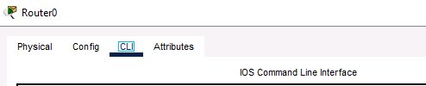
- In the console window, press Enter.
- You should see the device name displayed as follows:
Router0>
- At the prompt, type the following command and press Enter:
Show IP route
- This displays the routing table of Router0. You will see that the routing table contains a route for the following networks:
192.168.1.0 /24
130.30.10.0/16
There is no route present for the network 192.168.2.0 /24.
- Attempt to reach the 192.168.2.0 network by typing the following command and press Enter:
Ping 192.168.2.254
Ping 192.168.1.2.1
- Both pings are unsuccessful.
- Close router0 connection window.

Step 3: Connect to router1
In this task, you will connect to the console of the router1 and test reachability. Connectivity can be verified by confirming that all connections are green on the topology diagram. This indicates the interface are enabled and a link is established.
Perform the following steps:
- Select the router1 in the diagram.
- Ensure the CLI tab is selected.
- In the console window, press Enter.
- You should see the device name displayed as follows:
Router1>
- At the prompt, type the following command and press Enter:
Show IP route
- This displays the routing table. You will see that the routing table contains a route for the following networks:
130.30.10.0 /16
192.168.1.0 /24
There is no route present for the network 192.168.1.0 /24
- Attempt to reach the 192.168.1.0 network by typing the following command and press Enter:
Ping 192.168.1.254
Ping 192.168.1.1
- Both pings are unsuccessful.
- Close router1 connection window.

Step 4: Connect to router0 and configure RIPv2
In this task, router0 must be configured with RIPv2 using the CLI.
Perform the following steps and press enter after entering each command:
- Select router0, make sure the CLI tab is selected, and press Enter.
- In the prompt the following command and press Enter:
enable
This places you in privilege exec mode which provides additional permissions. The prompt changes from Router0> to Router0# (hash symbol):
Router0#
- In the prompt, type the following command and press Enter:
Configure terminal
You are now placed in global configuration mode which allows device-wide configuration and displayed as:
Router0 (config)#
- To configure dynamic routing, you will navigate into router configuration mode using the router keyword command. You will now manually configure RIPv2 by entering the command using the format:
Router0 (config)# router rip
Router0(config-router)#

- Type the following syntax to configure RIPv2 on the router as the routing protocol, so it can advertise the appropriate connected networks:
Router0(config-router)# version 2
Router0(config-router)# network 192.168.1.0 Router0(config-router)# network 130.20.10.0
config-router)# end
Router0#
Router#

Step 5: Connect to router1 and configure RIPv2
In this task, router1 must be configured with RIPv2 using the CLI.
Perform the following steps and press enter after entering each command:
- Select router1, make sure the CLI tab is selected, and press Enter.
- In the prompt the following command and press Enter:
enable
This place you in privilege exec mode which provides additional permissions. The prompt changes from Router1> to Router1# (hash symbol):
Router1#
- In the prompt type the following command and press Enter:
Configure terminal
You are now placed in global configuration mode which allows device-wide configuration and displayed as:
Router1 (config)#
- To configure dynamic routing, you will navigate into router configuration mode using the router keyword command. You will now manually configure RIPv2 by entering the command using the format:
Router1 (config)# router rip
Router1(config-router)#
- Type the following syntax to configure RIPv2 on the router as the routing protocol, and advertise the appropriate connected networks:
Router1(config-router)# version 2
Router1(config-router)# network 192.168.2.0
Router1(config-router)# network 130.20.10.0
Router1(config-router)# end
Router1#
Router#

Step 6: Test the dynamic RIP configuration
In this step, you will confirm that all links are connected by sending a ping to each of the routers IP addresses.
Perform the following:
- To confirm reachability exists to other networks from router0, attempt to reach the remote network connected to router1 (192.168.1.0) network by typing the following command and press Enter:
ping 192.168.2.254
ping 192.168.2.1
Both pings are successful compared to when we pinged the addresses earlier on.

Extension
What is the main difference between RIPv1 and RIPv2? Why is RIPv2 preferred?

How does RIPv2 use multicast for updates, and why is this approach beneficial?

How does the maximum hop count limit in RIPv2 impact network scalability?

In what scenarios would RIPv2 still be a viable option today, despite the availability of more advanced protocols like OSPF or EIGRP?

Activity 20: Dynamic routing lab EIGRP

Background
When working in any network environment, such as a corporate network or lab environment, it’s important to know how to implement dynamic routing protocols in order to exchange routing information for selecting the appropriate path for packet forwarding between network routers.
In this activity, you will examine device configuration using Packet Tracer. You will then configure dynamic routing using Cisco’s Enhanced Interior Gateway Routing Protocol (EIGRP) to discover remote networks and ensure reachability throughout the network. Connectivity already exists but not all networks are accessible. The Job Aid displays the existing configuration on all routers in the activity.
Device name | Interface | IP address | Connection to
Atlanta | Gi 0/0 | 10.101.1.1 /30 | Gi0/0 New-York
 | Gi 0/2 | 10.103.1.1 /30 | Gi0/2 Chicago
New-York | Gi 0/0 | 10.101.1.2 /30 | Gi0/0 Atlanta
 | Gi 0/1 | 10.102.1.1 /30 | Gi0/1 Chicago
Chicago | Gi 0/1 | 10.102.1.2 /30 | Gi0/1 New-York
 | Gi 0/2 | 10.103.1.2 /30 | Gi0/2 Atlanta

Instructions

Task 1: Confirm existing reachability

Step 1: Connect to the Atlanta router
In this task, you will connect to the console of the Atlanta router and test reachability. Connectivity can be verified by confirming that all connections are green on the topology diagram. This indicates the interface are enabled and a link is established.
Perform the following steps:
- Select the Atlanta router in the diagram.
- Ensure the CLI tab is selected.
- In the console window, press Enter.
- You should see the device name displayed as follows:
Atlanta>

- At the prompt, type the following command and press Enter:
Show IP route
This displays the routing table for the Atlanta router. You will see that the routing table contains a route for the following networks:
10.101.1.0 /30
10.103.1.0 /30
There is no route present for the network 10.102.1.0 /30 that exists between New-York and Chicago routers.
- Attempt to reach the 10.102.1.0 network by typing the following command and press Enter:
Ping 10.102.1.1
Ping 10.102.1.2
Both pings will be unsuccessful.
- Close the Atlanta router connection window.

Step 2: Connect to the New-York router
In this task, you will connect to the console of the New-York router and test reachability.
Perform the following steps:
- Select the New-York router in the diagram.
- Ensure the CLI tab is selected.
- In the console window, press Enter.
- You should see the device name displayed as follows:
New-York>
- At the prompt, type the following command and press Enter:
Show IP route
- This displays the routing table for the New-York router. You will see that the routing table contains a route for the following networks:
10.101.1.0 /30
10.102.1.0 /30
There is no route present for the network 10.103.1.0 /30 that exists between Atlanta and Chicago routers.
- Attempt to reach the 10.103.1.0 network by typing the following command and press Enter:
Ping 10.103.1.1
Ping 10.103.1.2
Both pings will be unsuccessful.
- Close the New-York router connection window.
Step 3: Connect to the Chicago router
In this task, you will connect to the console of the Chicago router and test reachability.
Perform the following steps:
- Click the Chicago router in the diagram.
- Ensure the CLI tab is selected.
- In the console window, press Enter.
- You should see the device name displayed as follows:
Chicago>
- At the prompt, type the following command and press Enter:
Show IP route
This displays the routing table for the Chicago router. You will see that the routing table contains a route for the following networks:
10.102.1.0 /30
10.103.1.0 /30
There is no route present for the network 10.101.1.0 /30 that exists between Atlanta and Chicago routers.
- Attempt to reach the 10.101.1.0 network by typing the following command and press Enter:
Ping 10.101.1.1
Ping 10.101.1.2
Both pings will be unsuccessful.
- To confirm reachability exists to other networks, attempt to reach the 10.102.1.0 network by typing the following command and press Enter:
Ping 10.102.1.1
Ping 10.102.1.2
Both pings are successful. The success rate may be 80% because initially there was no ARP information for the destination. An ARP request was sent, followed by the ICMP ping packet.
- Repeat the ping to verify 100% success rate.
- Close the Chicago router connection window.

Task 2: Configure EIGRP on the Atlanta router
In this task, the Atlanta router must be configured with EIGRP. The organisation uses the Autonomous System Number (ASN) 100 for their internal networks. EIGRP will be configured on all interfaces.
Perform the following steps:
- Select the Atlanta router in the diagram and press Enter.
- In the prompt the following command and press Enter:
enable
This places you in privilege exec mode which provides additional permissions. The prompt changes from Atlanta> to Atlanta# (hash symbol).
- In the prompt type the following command and press Enter:
Configure terminal
You are now placed in global configuration mode which allows device-wide configuration and displayed as Atlanta(config)#.
- To configure dynamic routing, you will navigate into router configuration mode using the router keyword command. You will now manually configure EIGRP by entering the command using the format:
Router <protocol> <ASN>
- In the prompt type the following command and press Enter:
Router EIGRP 100
- The prompt will change to Atlanta(config-router)# indicating you are currently in router configuration mode for ASN 100.
The next step is to enter the network identities which EIGRP will advertise. The EIGRP configuration uses a specific making technique for the subnet mask called wildcard-masking.
Just like a subnet mask, a wildcard mask is 32 bits long. It acts as an inverted subnet mask, but with a wildcard mask, the zero bits indicate that the corresponding bit position must match the same bit position in the IP address (the network ID). The one bits indicate that the corresponding bit position doesn’t have to match the bit position in the IP address (the host ID).
For example, an 8-bit mask or /8 would look like the following:
11111111.00000000.00000000.00000000

If the bits are inverted, zeros are used to represent /8. Resulting in:
00000000.11111111.11111111.11111111
The wild card mask for /8 is now identified as 0.255.255.255
- To enable EIGRP to establish a neighbour and advertise the Atlanta to New-York network type the following command:
Network 10.101.1.0 0.0.0.255
Although the network uses /30, the network command used advertises the whole 10.101.1.0 subnet, rather than just the two configured IP addresses.
- To enable EIGRP to establish a neighbour and advertise the Atlanta to Chicago network, type the following command:
Network 10.103.1.0 0.0.0.255
Once again, although the network uses /30, the network command used advertises the whole 10.103.1.0 subnet, rather than just the two configured IP addresses.
At present, no neighbour relationship can be established because only a single router has been configured for EIGRP dynamic routing.

Task 3: Configure EIGRP on the New-York router
In this task, the New-York router must be configured with EIGRP for the Autonomous System Number (ASN) 100. EIGRP will be configured on all interfaces.
Perform the following steps:
- Select the New-York router in the diagram and press Enter.
- In the prompt type the following command and press Enter:
enable
This places you in privilege exec mode which provides additional permissions. The prompt changes from New-York> to New-York# (hash symbol).
- In the prompt, type the following command and press Enter:
Configure terminal
You are now placed in global configuration mode which allows device-wide configuration and displayed as New-York(config)#.
- To configure dynamic routing, you will navigate into router configuration mode using the router keyword command. You will now manually configure EIGRP by entering the command using the format:
Router <protocol> <ASN>

- In the prompt, type the following command and press Enter:
Router EIGRP 100
The prompt will change to New-York(config-router)# indicating you are currently in router configuration mode for ASN 100.
The next step is to enter the network identities which will be advertised using EIGRP.
- To enable EIGRP to establish a neighbour and advertise the New-York to Atlanta network, type the following command:
Network 10.101.1.0 0.0.0.255
- You will receive a message in the console window that indicates a new adjacency has been established. A new neighbour with the IP address 10.101.1.1 has been discovered. This is the Atlanta router you configured in the previous task.
- To enable EIGRP to establish a neighbour and advertise the New-York to Chicago network, type the following command:
Network 10.102.1.0 0.0.0.255
At present, no neighbour relationship can be established because only the New-York router has been configured for EIGRP dynamic routing in this network.

Task 4: Configure EIGRP on the Chicago router
In this task, the Chicago router must be configured with EIGRP for the Autonomous System Number (ASN) 100. EIGRP will be configured on all interfaces.
Perform the following steps:
- Select the Chicago router in the diagram and press Enter.
- In the prompt the following command and press Enter:
enable
This places you in privilege exec mode which provides additional permissions. The prompt changes from Chicago> to Chicago# (hash symbol).
- In the prompt type the following command and press Enter:
Configure terminal
You are now placed in global configuration mode which allows device-wide configuration and is displayed as Chicago(config)#.
- To configure dynamic routing, you will navigate into router configuration mode using the router keyword command. You will now manually configure EIGRP by entering the command using the format:
Router <protocol> <ASN>
- In the prompt, type the following command and press Enter:
Router EIGRP 100
The prompt will change to Chicago(config-router)# indicating you are currently in router configuration mode for ASN 100.
- The next step is to enter the network identities which will be advertised using EIGRP.
To enable EIGRP to establish a neighbour and advertise the Chicago to network, type the following command:
Network 10.102.1.0 0.0.0.255
- You will receive a message in the console window that indicates a new adjacency has been established. A new neighbour with the IP address 10.102.1.1 has been discovered. This is the New-York router that you configured in the previous task.
- To enable EIGRP to establish a neighbour and advertise the Chicago to Atlanta network, type the following command:
Network 10.103.1.0 0.0.0.255
- You will receive a message in the console window that indicates a new adjacency has been established. A new neighbour with the IP address 10.103.1.1 has been discovered. This is the Atlanta router that you configured in task 2.

Task 5: Verify reachability
In this step, you will confirm that all links are connected by sending a ping to each of the routers IP addresses.
Perform the following:
- To confirm reachability exists to other networks from the Chicago router, attempt to reach the remote network between Atlanta and New-York (10.101.1.0) network by typing the following command and press Enter:
Do ping 10.101.1.1
Do ping 10.101.1.2
Both pings will be successful.
- Examine the Chicago routing table. Type the following command and press Enter:
Do show IP route
The routing table displays a route with the Code ‘D’ which indicates the network learned is EIGRP. Notice the network 10.101.0.0 has two entries. Both entries display the EIGRP Administrative Distance of 90. This means both paths are based on EIGRP. Now examine the Metric. Both Metrics are identical. This is because Chicago router has a Gigabit Ethernet connection to both Atlanta and New-York, which have the same bandwidth and delay across those links. As a result, there are equal (load-balanced) paths to the destination.
In order to select a preferred path, for example, via New-York router, the interface bandwidth or delay can be adjusted to modify the overall Metric. The bandwidth of an interface, currently Gigabit (1000 Mbps), can be adjusted to a lower amount.
- Navigate to the interface which will be reduced by typing the following command and press Enter:
Interface gigabitethernet0/1
The prompt will change to Chicago(config-if)# indicating you are currently in interface configuration mode. The actual interface identity is not displayed (for example, Gi0/1).
- To express a reduced bandwidth from 1Gbps (1000Mbps) to 100Mbps, the command uses kilobits formula. 100Mbps in kilobits is expressed as 100000.
- Type the following command and press Enter:
Bandwidth 100000
The neighbour relationship will go down and then return to a new adjacency.
- After forming a new adjacency, examine the routing table to view the changes. Type the following command and press Enter:
Do show IP route
Notice only a single path now exits. EIGRP does not show the path with reduced bandwidth. As the adjustment to bandwidth made the Metric higher, EIGRP has not selected the link as the best path to the destination. Remember, only the best path is added to the routing table.
The best path to the network between Atlanta and New-York from Chicago is now via the New-York router only. If for any reason that network path is unavailable, a new route can be added to the routing table, the path via Atlanta, as it will become the best path to the destination.
- At the prompt, type the following commands and press Enter:
Interface gigabitethernet0/2
Shutdown
This command has disabled the link with a valid path in the routing table. As a result, the existing single path will be removed and a new path (if one exists) can be identified and update the routing table.
- Inspect the routing table and determine a new path exists (with a higher Metric than previous). To inspect the routing table, type the following command and press Enter:
Do show IP route
If the original best path interface is brought online, a new adjacency will be established and the routing table updated.
- Bring the interface online by typing the following command and press Enter:
No shutdown
- You have completed the configuration of EIGRP dynamic routing.

Activity 21: Recommend a cloud deployment model and service type

Scenario background
You are the IT manager for a growing company that is considering moving its infrastructure to the cloud. Your task is to evaluate different cloud solutions and make recommendations based on the company's needs.
Business profile:
- Industry: E-commerce.
- Current Infrastructure: On-premises servers, limited scalability, high maintenance costs.
- Goals: Improve scalability, reduce costs, enhance disaster recovery, and increase flexibility.

Instructions
Research the following areas:
- Cloud deployment models: Research public, private, hybrid, and community cloud models. Identify which model best suits the company's needs.
- Cloud service models: Evaluate IaaS, PaaS, and SaaS. Determine which services the company should adopt for different applications (for example, website hosting, database management, software development).
- Benefits and drawbacks: List the potential benefits and drawbacks of moving to the cloud. Consider factors such as cost, security, and performance.
Based on your research, select the best options for the business:
- Deployment model decision: Based on your research, decide which cloud deployment model the company should adopt. Justify your choice.
- Service model decision: Choose the appropriate cloud service models for different applications within the company. Explain your reasoning.
- VM usage: Determine how the company can use VMs to improve operations. Consider aspects like application deployment, testing, and disaster recovery.
Prepare a presentation summarising your decisions and recommendations.

Include the following sections:
- Introduction: Brief overview of the company's current situation and goals.
- Research findings: Summary of your research on deployment and service models, benefits, and drawbacks.
- Recommendations: Detailed explanation of your decisions regarding deployment model, service models, virtualisation, hypervisor type, and VM usage.
- Conclusion: Final thoughts and potential next steps for the company.

Discussion and feedback
Present your findings to a group.
Reflect on the feedback and consider any adjustments to your recommendations.



